OUBOV_TC_02_Sell Call Option Double Knout In FXO

This test case validates that a Sell Call Option Double Knout In FXO transaction created  
in UOB WUI was reflected in UOB OneView after successful transaction

Order Checked

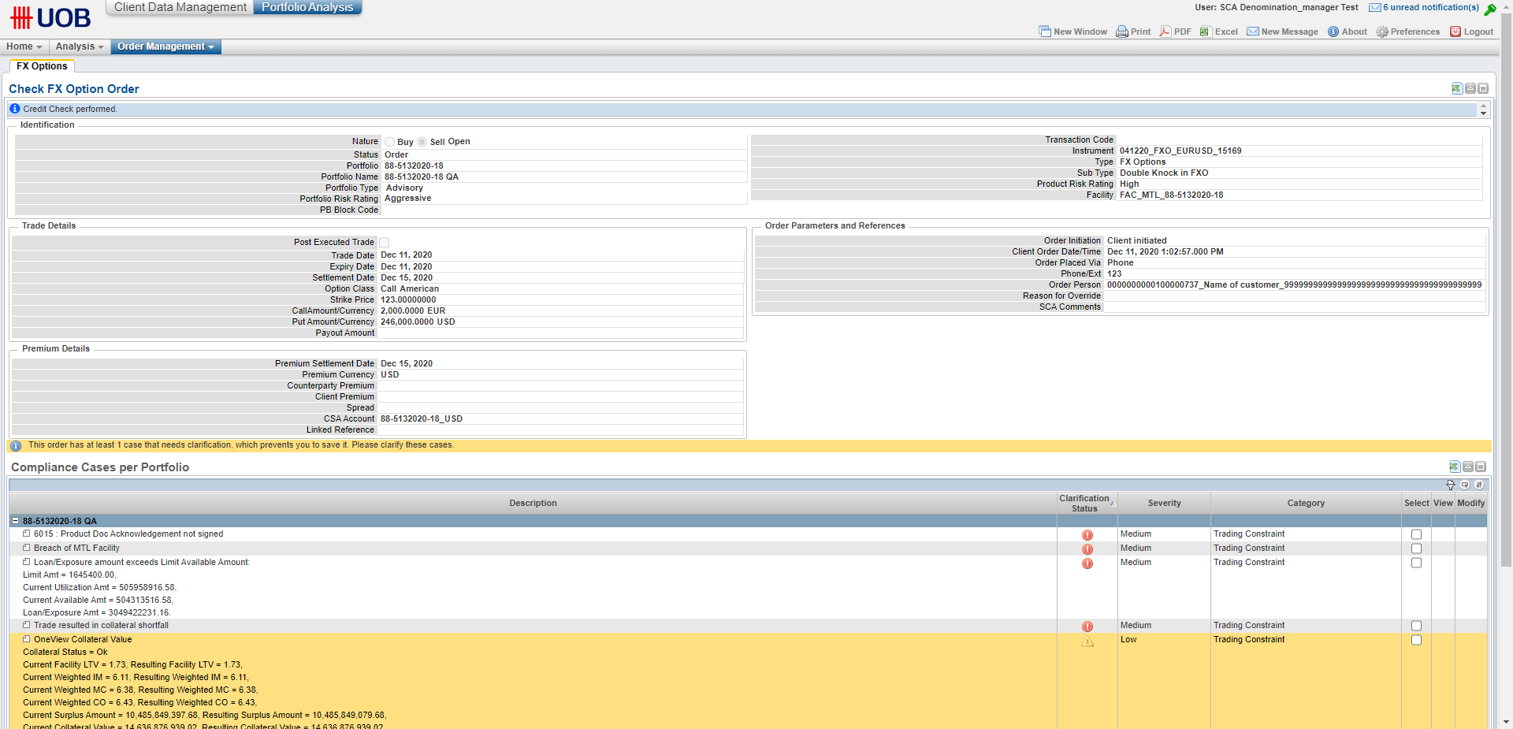

Compliance Cases – 7

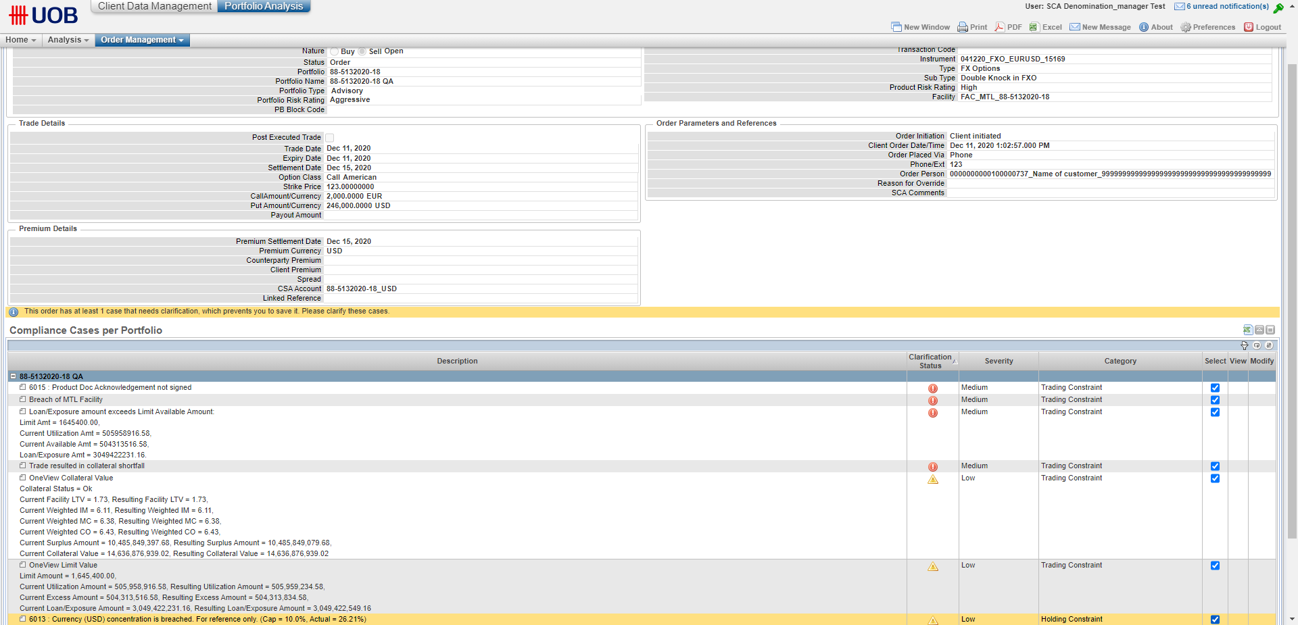

Compliance Cases Resolved

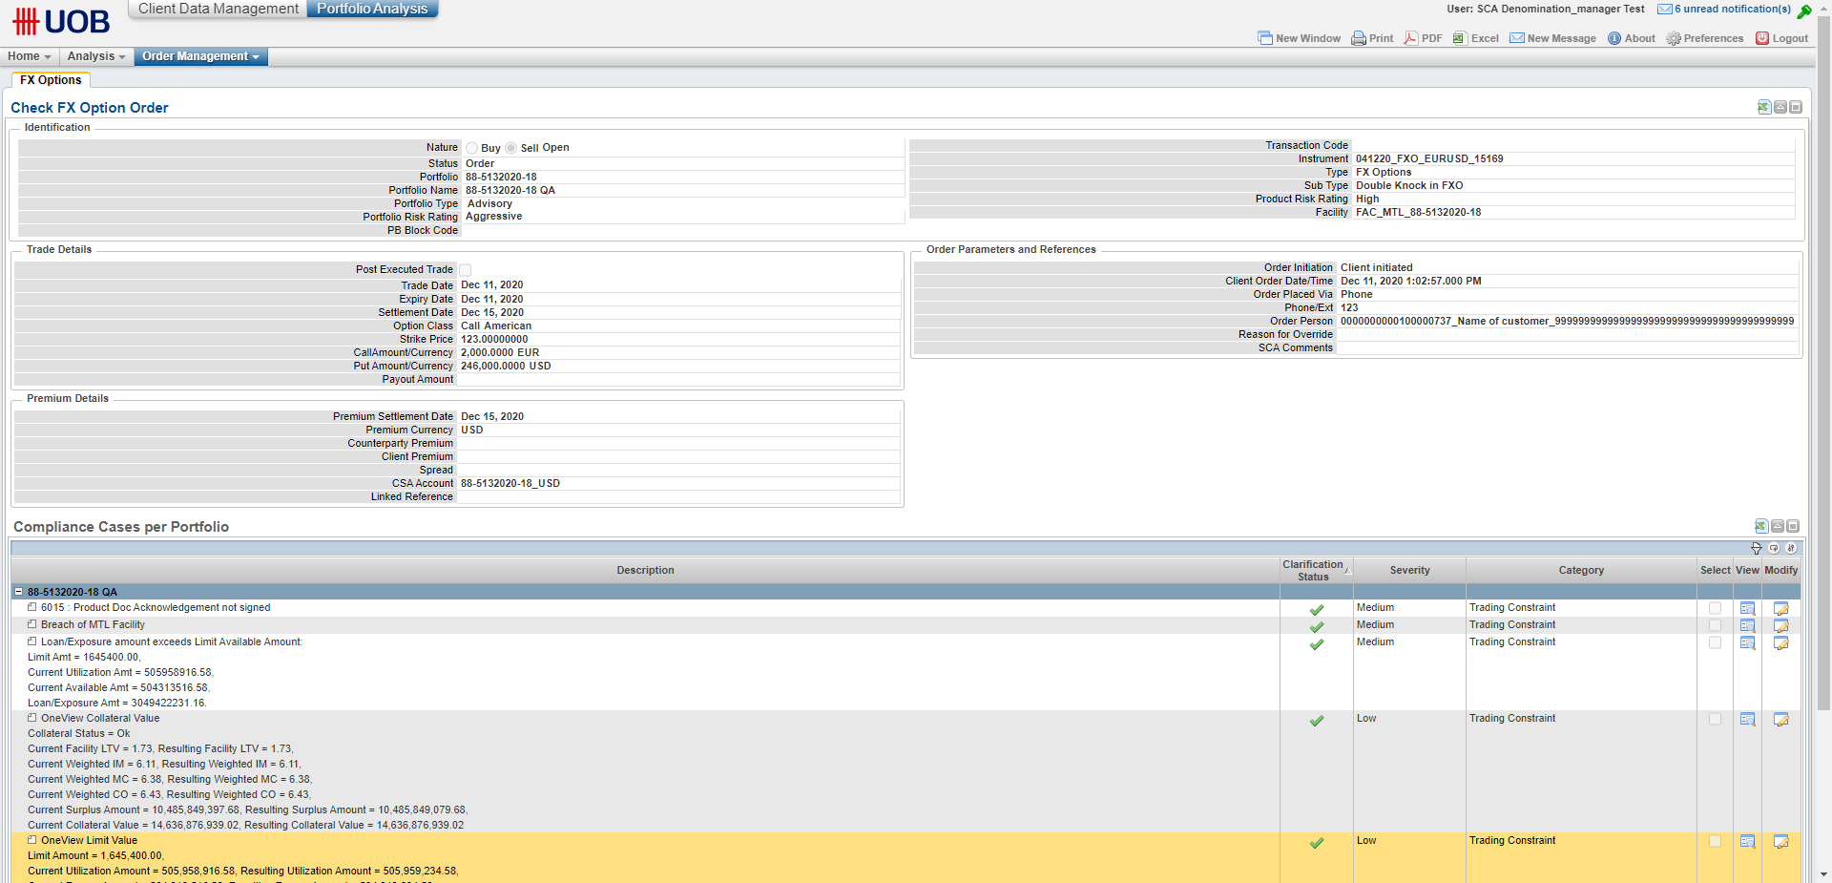

Order Transaction Code A88-5132020-10000701

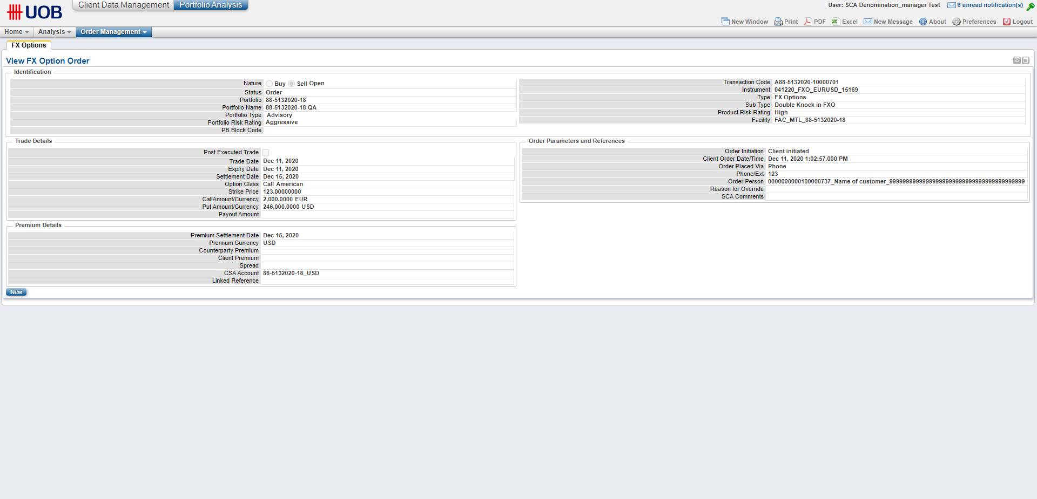

Signed in as Credit User 2

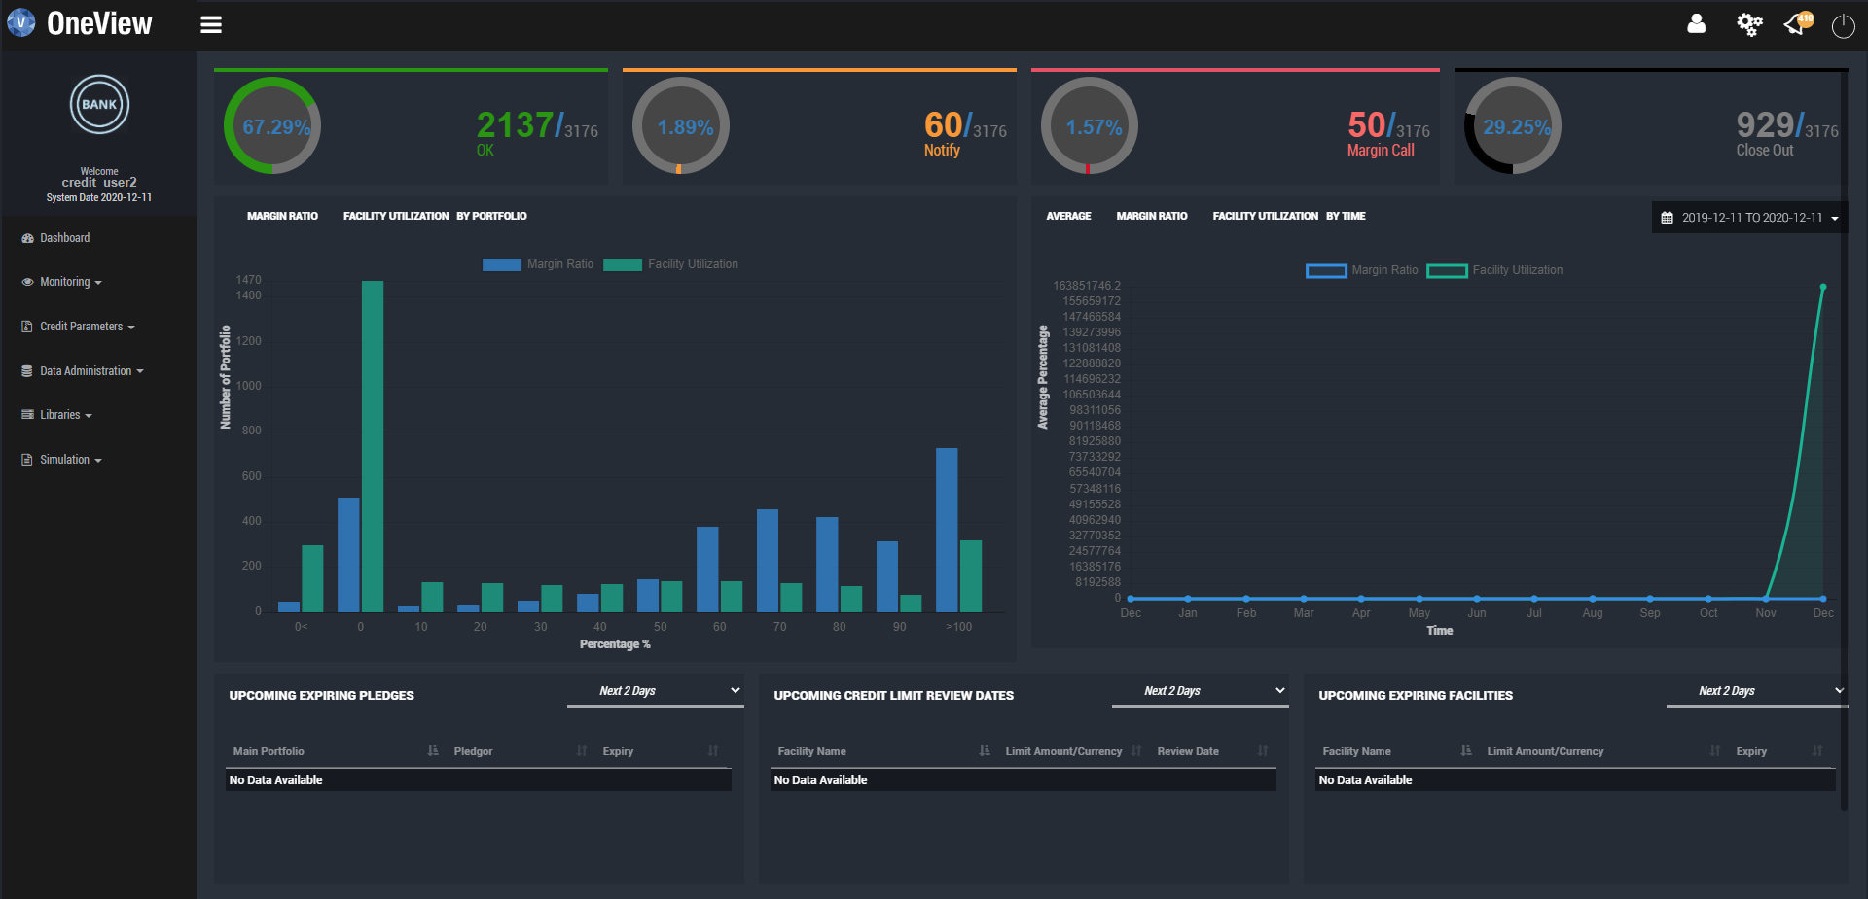

Liabilities screen

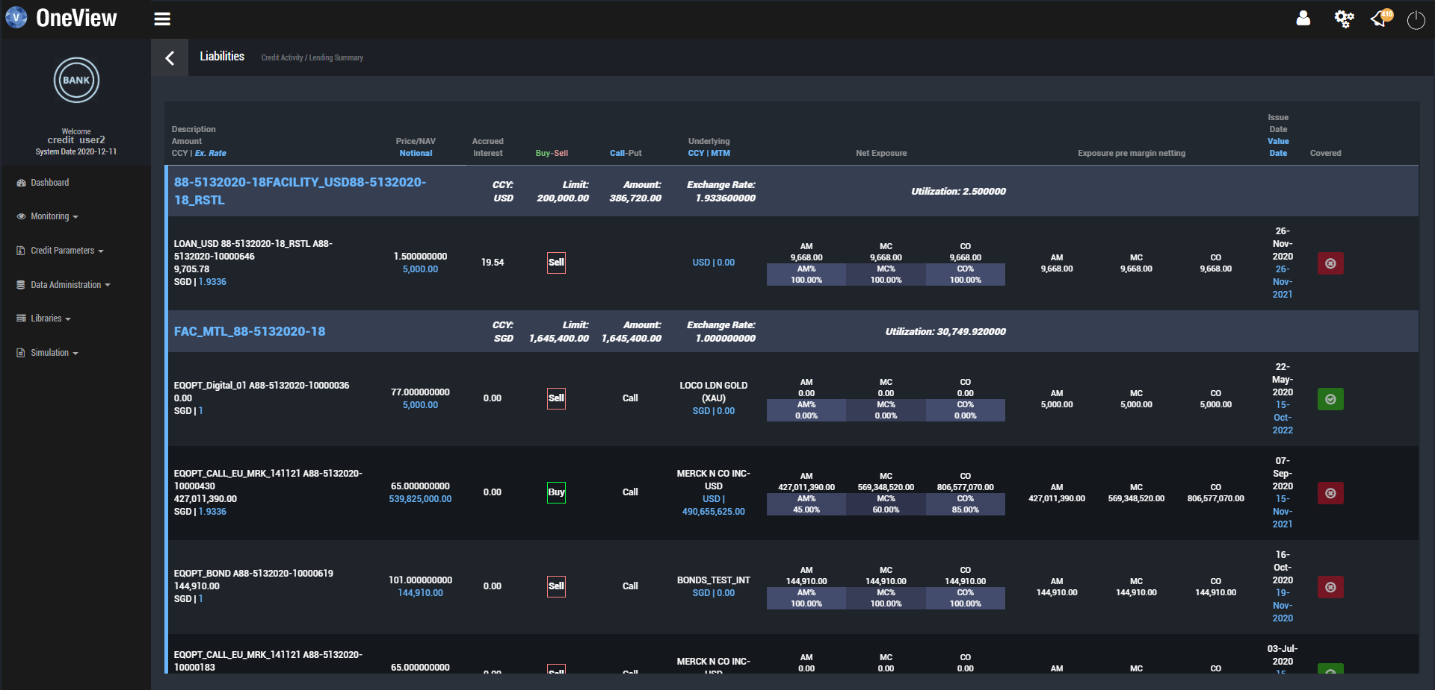

Instrument 041220_FXO_EURUSD_15169 is displayed

